Why the CarSwitch App Is Trusted Across the UAE Car Market
Focus keyword: CarSwitch App UAE
Meta title: Why the CarSwitch App Is Trusted Across the UAE Car Market
Meta description: Discover why the CarSwitch app is trusted across the UAE car market. Learn how certified inspections, transparent pricing, secure payments, and smooth processes make buying and selling used cars stress-free.

Feature image
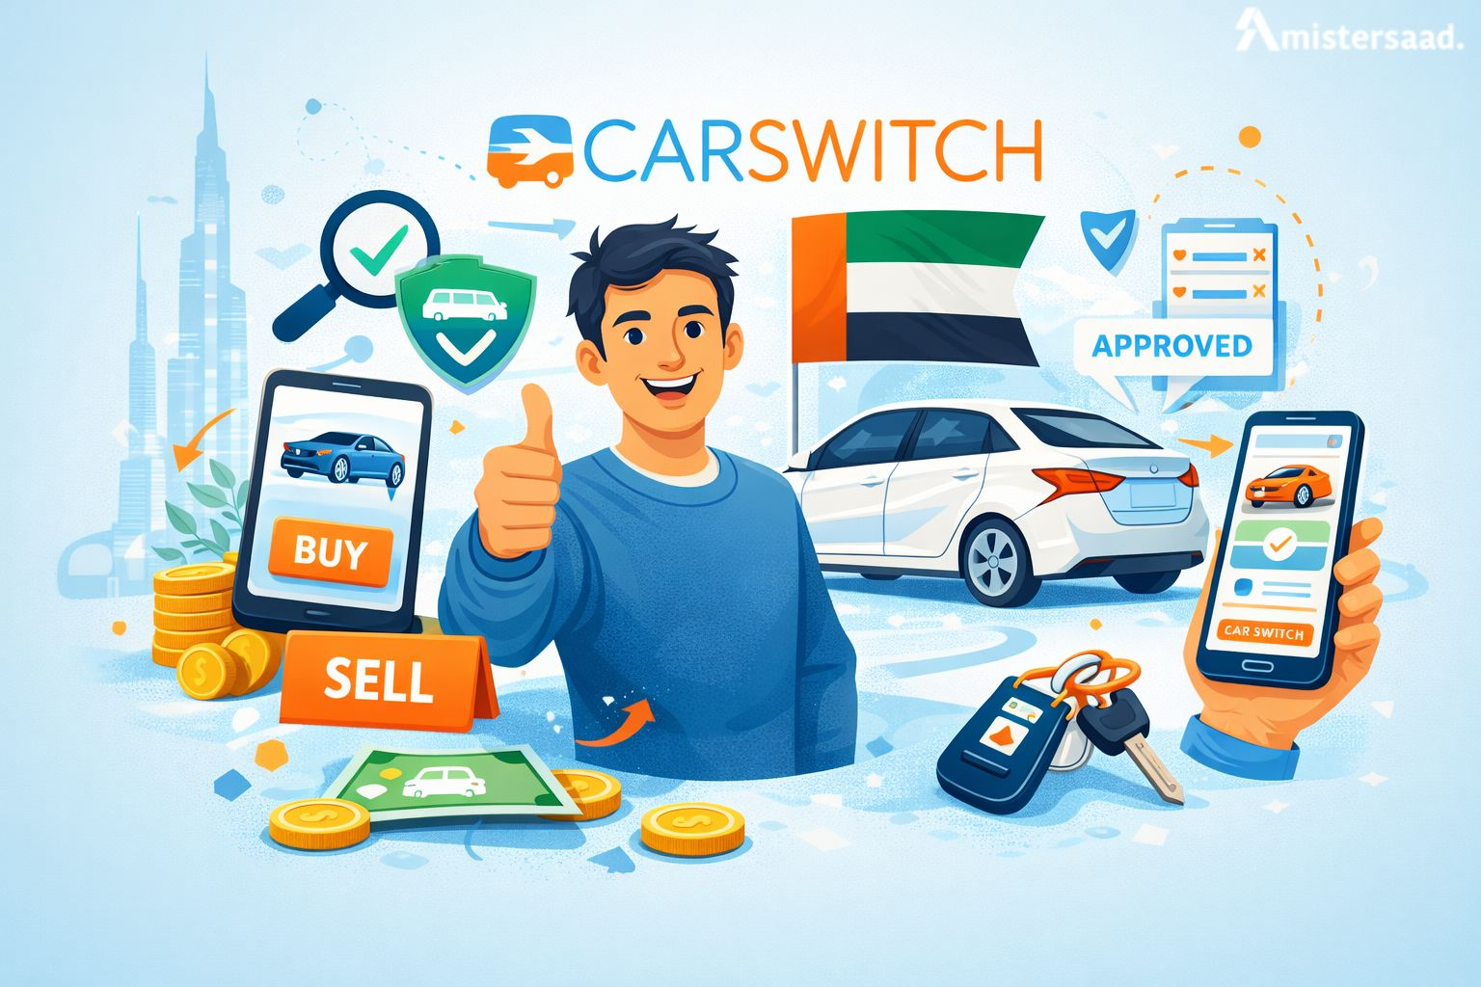
CarSwitch UAE has become one of the most trusted platforms for buying and selling used cars. The platform offers a simple and secure method for both buyers and sellers. It removes confusion from the car market and brings confidence to every step. The app manages inspections, pricing, negotiations and documents with complete care. Buyers get access to well inspected cars while sellers enjoy smooth processes. The platform targets transparency to reduce stress for every user. Its system protects users from hidden issues or unclear details. It works with trained teams to ensure safe transactions. Each listing includes essential information that supports informed decisions. The platform continues to grow across the country as more users trust its services. This experience sets CarSwitch apart in the UAE market. Many digital platforms highlight modern features but CarSwitch stands out for real value.

How CarSwitch Works for Buyers
CarSwitch offers buyers a simple and guided journey. The platform helps users search, compare and evaluate cars without pressure. Buyers receive accurate information to support smart choices. The team verifies the details of every listed car. The app focuses on trust by sharing clear inspection reports. Buyers enjoy a smooth process from browsing to final handover. Support teams assist at each step with clear instructions. Buyers avoid frustration and hidden risks. The platform handles documentation and transfers with professional care. Users can choose cars based on budget, features or personal needs. The system gives control and confidence to every buyer. It creates a balanced experience with clear tools and a friendly interface. It reduces stress linked with car shopping in busy markets. This buyer focused approach builds long term trust.

Easy Car Search and Filtering
CarSwitch helps buyers find the right car with powerful search features. Users can filter results by price, mileage or model. The system shows accurate results for every search. These filters save time and reduce confusion. Buyers can compare specifications easily. The platform updates listings regularly for reliability. Users browse confidently because results match preferences. Every filter improves the quality of the search. This approach supports faster decisions for buyers. Many users trust these features because they simplify car hunting. The app continues to improve its search tools for better user comfort. The platform keeps the entire process smooth and clear. Many users in this region also rely on skilled mobile experts. One example includes Mobile App Developer Dubai, known for building stable digital platforms.
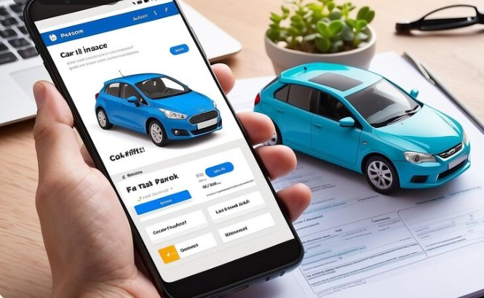

Certified Car Inspections
CarSwitch offers thorough inspections for all listed cars. Every inspection includes detailed checks of the interior and exterior. Technicians review major systems for safety. Buyers can trust the provided reports because they follow strict standards. These checks protect users from unexpected issues. Each report includes clear images and notes. Buyers gain full visibility before final decisions. The app updates every report with honest details. This transparency creates confidence for all buyers. Inspections help remove risk for new car owners. The platform ensures that every car meets quality expectations. These inspections support smarter and safer choices.

Professional Support and Test Drives
CarSwitch offers strong support for buyers throughout the process. Support teams answer questions and give helpful guidance. They arrange test drives for serious buyers. These drives help users understand car conditions clearly. The app coordinates every step with comfort and clarity. Buyers avoid unnecessary stress because the team handles arrangements. Support staff maintain professional communication at all times. This supportive system helps buyers finalize choices confidently. Test drives remain essential for user satisfaction. The app brings trust and convenience to every appointment. The process improves buyer experience through reliable assistance. Many digital platforms are built with care by specialists like Professional Mobile App Developer Dubai, respected for quality results.

Flexible Financing and Insurance Options
CarSwitch assists buyers by connecting them to financing partners. Buyers explore loan options that match their budgets. The platform also shares insurance choices with trusted providers. These services reduce the time spent researching on separate channels. Buyers can compare terms easily before making decisions. Financing options help users manage payments smoothly. Insurance support offers safe protection after purchase. The app ensures users feel secure with every step. These additional services complete the buying journey without stress. Buyers appreciate the convenience of these coordinated solutions.
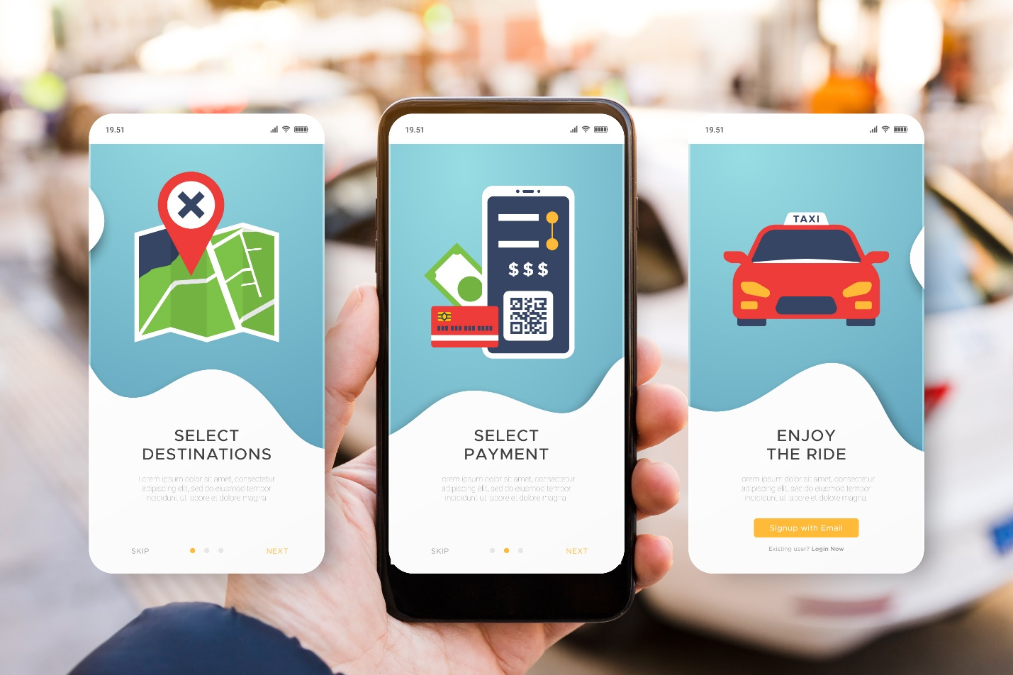

Guaranteed Transparency
CarSwitch highlights full transparency for all users. Buyers see verified information for every listing. The platform hides nothing from users. All reports and details come from trained inspectors. Each listing includes accurate market comparisons. The website shares ownership details and service history when available. Buyers view everything before scheduling visits. This open approach builds trust in the market. The app continues improving clarity for all customers. The system offers dependable tools for safe decisions. This clarity mirrors the work of skilled creators such as Best Mobile App Developer Dubai, known for delivering trusted digital experiences.

How CarSwitch Works for Sellers
CarSwitch gives sellers a smooth and hands-free experience. The platform manages inspections, listings, calls and offers for the seller. It handles market comparisons to set a fair price. Sellers do not meet buyers directly. The team takes care of appointment scheduling and communication. Sellers save time because CarSwitch manages everything professionally. The process reduces stress often linked with car selling. Sellers receive clear updates from start to finish. The platform offers safe handling of payments and documents. Many choose CarSwitch because it offers convenience without extra effort. Many sellers appreciate advanced platforms built through Mobile App Development Dubai, which improves reliability and user engagement.
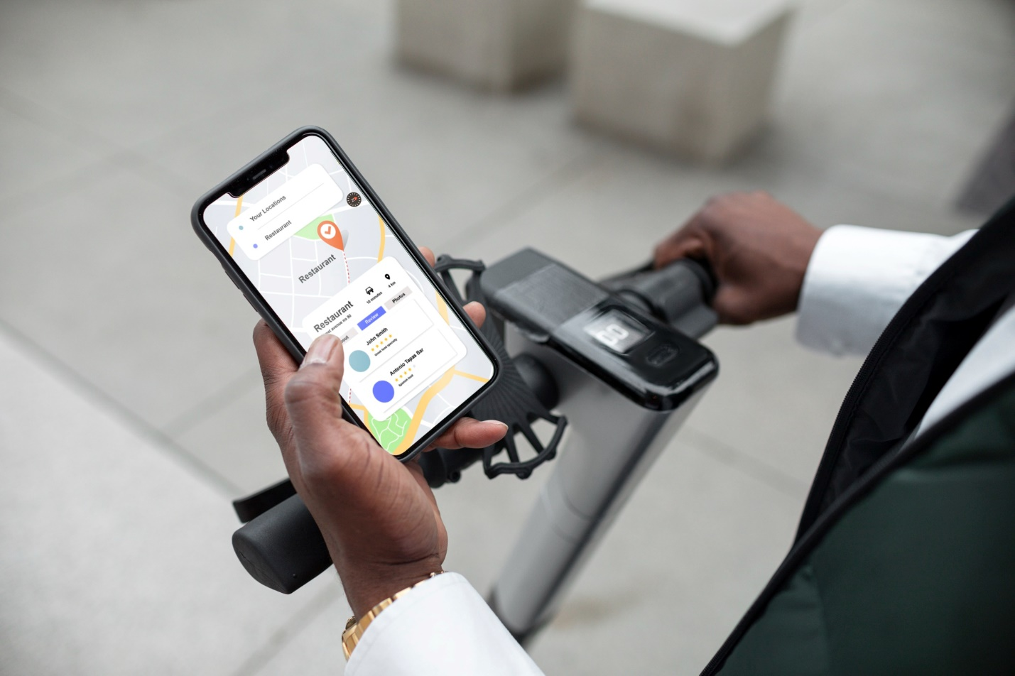

Hassle Free Car Listing
CarSwitch prepares every listing with clear information and quality photos. The team writes descriptions that match real car conditions. Sellers share basic details and CarSwitch handles the rest. The process removes confusion from the listing stage. Sellers avoid the challenge of writing their own text. The app publishes listings only after full inspection. This approach protects both buyers and sellers. The platform updates listings for accuracy. Every listing aims to attract serious buyers. The system supports sellers with effortless management.

Professional Car Inspection and Evaluation
CarSwitch completes a full inspection before listing any car. The team checks mechanical systems and body condition carefully. Inspectors prepare reports with clear notes for accuracy. These evaluations help sellers understand the real value of their cars. CarSwitch uses structured methods to check each part. Reports highlight strengths and note potential issues. This information prevents misunderstandings during negotiations. Sellers trust these evaluations because they follow strict standards. Buyers feel secure when reports show clear data. This inspection process supports fair pricing for everyone involved. The app continues improving its evaluation system to help more users. Many reliable inspection systems are supported by strong digital tools built by Custom Mobile App Developer Dubai, known for tailored user experiences.

No Inconvenient Viewings or Time Wasters
CarSwitch removes stressful viewings for sellers. The platform handles all appointments and buyer communication. Sellers do not meet buyers or answer repeated calls. It screens buyers before scheduling visits. This system prevents unnecessary interruptions and time loss. The team manages test drives and buyer checks. Sellers receive updates without active involvement. This approach saves time for busy professionals. The app keeps processes clean and organized. Sellers enjoy a smooth experience without pressure. This support reduces common frustrations faced in private car sales.

Secure Negotiation and Payment
CarSwitch handles negotiations on behalf of sellers. The team ensures fair offers based on real market data. Sellers avoid stressful conversations with buyers. CarSwitch protects both sides through documented communication. Payment processes follow secure methods for safety. The team supervises each step for accuracy. Sellers receive money without confusion or uncertainty. The platform prevents fraud by using controlled procedures. Sellers depend on this trusted method for secure transactions. Secure digital systems often improve with guidance from specialists like UAE Mobile App Developer, known for building trusted platforms.

Results That Speak for Themselves
CarSwitch delivers reliable results for both buyers and sellers. The platform manages thousands of successful transactions every year. Users highlight smooth processes and clear communication. Sellers receive fair prices based on market data. Buyers enjoy safe and transparent journeys. Many users return because they trust the system. CarSwitch improves its tools to meet rising demand. The platform keeps workflows predictable for all customers. These results build strong confidence in the service.

CarSwitch Dubai: A Hotbed of Quick Deals
Dubai remains one of the busiest car markets in the region. CarSwitch uses this active market to support quick deals for residents. The platform connects motivated sellers with serious buyers. Many users find deals faster because demand stays high. CarSwitch lists cars that pass strict inspection standards. Buyers trust these verified listings and respond quickly. Sellers benefit from steady interest and smooth processes. The platform manages each step with organized systems. Dubai’s diverse lifestyles and regular car upgrades keep activity strong. This environment supports fast sales and confident purchases. Many residents choose the service for its speed and dependability. Its presence in Dubai continues to grow because results remain positive. People value quick deals supported by full transparency.

Why CarSwitch is Trusted Across the UAE
CarSwitch has earned trust across the UAE because of its clear and user-friendly methods. The platform removes stress linked with private car sales. Buyers and sellers feel safe through structured systems. Trained teams manage inspections, pricing and communication. This builds strong confidence for every user. Tools continue improving for smoother experiences. People value honest data and secure steps. Families across the UAE rely on the platform because it reduces risks. Verified reports prevent hidden issues and protect users. Trust grows because results stay consistent. Residents depend on this safe and organized structure.
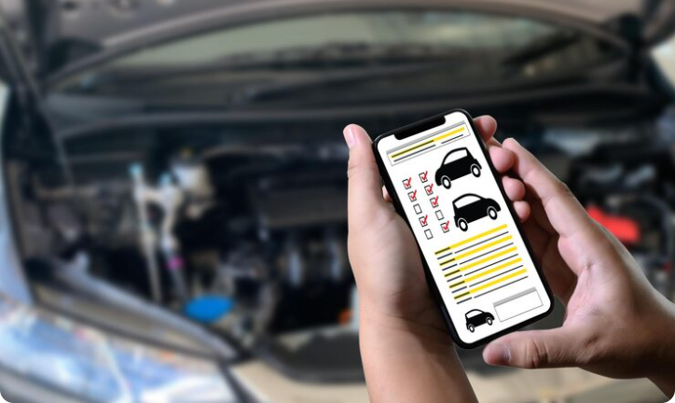

Certified Vehicle Inspections
CarSwitch performs certified inspections for all cars before listing. Inspectors follow strict guidelines for every check. Reports include clear notes, photos and measured details. Buyers gain full visibility of car condition. Sellers feel secure because the system maintains fairness. Certified checks prevent disputes during negotiations. This process builds strong confidence in the platform.

Data Backed Pricing
CarSwitch sets prices using market data and real trends. The system reviews current listings and recent sales. This method helps sellers avoid unrealistic pricing. Buyers benefit from honest and balanced values. The platform uses updated reports for better accuracy. This strategy supports quicker deals and fair negotiations. Users see transparency at every step. CarSwitch continues enhancing pricing tools for stronger results. Digital systems with smart pricing features often result from strong planning by Best Mobile App Developer Dubai, known for advanced market logic.

Excellent User Ratings
CarSwitch maintains high user ratings across the UAE. Customers appreciate fast processes and reliable support. Positive reviews highlight professional communication. The platform earns trust through consistent performance. Many users recommend CarSwitch to family and friends. High ratings come from honest inspections and smooth processes. Buyers enjoy safe journeys with no hidden concerns. Sellers receive clear updates from start to finish. These ratings reinforce CarSwitch as a leading platform. The company continues improving services to meet user expectations.

No Last-Minute Surprises or Hidden Fees
CarSwitch protects users from last minute issues or extra charges. The platform presents each detail clearly before confirmation. Buyers receive complete inspection data and pricing information. Sellers know all required steps in advance. This system removes financial confusion. The app maintains honest communication across the entire process. Users trust the platform because it prevents unexpected costs. Clear information supports smooth negotiations and safe payments. The platform continues improving systems for more clarity. Strong transparency like this is supported by modern solutions often shaped by App Developer Dubai, known for clean digital structures.

One Platform Complete Process
CarSwitch keeps the entire process on one organized platform. Buyers search with structured filters. Sellers list cars without stress. All communication stays within the system for safety. Inspections, pricing, test drives and payments run through controlled steps. Users avoid confusion because everything stays connected. This single platform approach saves time. People feel confident because the workflow remains predictable.

Mistersaad Building the Best UAE Mobile Apps
Digital platforms grow through smart development and user centered design. Mistersaad supports many businesses through strong mobile solutions. He builds clean and modern applications that improve user engagement. These apps help companies meet customer needs with clarity. Mistersaad focuses on smooth experiences and reliable features. Many UAE businesses trust the team for consistent work quality. This support helps platforms like CarSwitch grow stronger through better technology. He designs with careful attention to speed and functionality.

Conclusion
CarSwitch remains a trusted platform for buying and selling used cars in the UAE. The system supports users with transparent processes and professional guidance. Buyers receive complete inspection reports and secure steps. Sellers enjoy organized listings and safe negotiations. The platform protects both sides through clear information and structured workflows. Don't forget, your next intelligent car decision is at the tip of your hand.

FAQs
What makes CarSwitch different from other car selling platforms?
CarSwitch manages inspections, pricing and communication within one controlled system. Users gain clear information at every step.
How does CarSwitch help buyers make safe decisions?
Buyers receive certified inspection reports for each car. These reports highlight important details before any test drive.
Can sellers trust the pricing process?
Yes. The app uses real market data to set accurate prices. This prevents unrealistic expectations.
Do buyers meet sellers directly?
No. CarSwitch manages all meetings and test drives. Sellers avoid time consuming conversations.
